

**SOFTWARE REQUIREMENT SPECIFICATION**

**<--HOTEL MANAGE SYSTEM – HMS-->**

**Team Contributions**

|  |  |  |
| --- | --- | --- |
| ***#*** | ***Full Name*** | ***In charge*** |
| 1 | Ngô Anh Tú |  |
| 2 | Lê Trung Sang |  |
| 3 | Trần Xuân Sơn |  |
| 4 | Bùi Đình Chung |  |
| 5 | Bùi Duy Khải |  |

– Hanoi, January 2020 –

**TABLE OF CONTENT**

## **1. Business Requirements**

### **1.1 Background**

To meet the needs of residents, tourists in hotels and mini apartments are thriving in areas near schools, industrial parks, tourist resorts, and corporate offices. , big business. Instead of managing information manually, many hoteliers have turned to hotel management software to help with their work. Hotel management software is software designed to store, classify as well as provide support tools to help manage hotels and mini-apartments in the most convenient and efficient way. Using management software, you will avoid the countless problems that book management can cause.

### **1.2 Business Opportunity**

If you are not the type of person who is meticulous, careful, know how to organize information logically, scientifically and effectively, the use of management software will help your work become convenient, light and key. body.

Using management software to easily grasp the situation and information of a room without having to go to each place or check in a pile of thick books.

You should use hotel management software if you need to spend more time on other tasks. The use of software helps you manage hotel situations effectively even if you do not regularly review the specific situation, the data is carefully stored, easy to look up, with pre-installed announcements when it comes to the calendar. check-out appointment, room rental, monthly collection.

### **1.3 Assumptions & Dependencies**

AS-1: Information management of hotel tenants.

AS-2: Manage room information for dividing room rates.

AS-3: Financial management.

AS-4: Manage furniture and equipment of the inn.

# **I. Business Requirements**

## **2. Scope and Limitations**

### **2.1 Major Features**

FE-01: Reservations and payment of rooms.

FE-03: Create, view, modify, and unsubscribe from meals for rooms periodically or daily.

FE-04: Create, view, modify, delete and archive rooms.

FE-05: View ingredient list and room information for customer.

### **2.2 Limitations & Exclusions**

LI-1: The page will only be used for students as well as clients living around the Hoa Lac area.

# II. User Requirements

## 1. Overall Description

### 1.1 User Classes (Actors)

|  |  |
| --- | --- |
| Admin | Account management as well as all the information provided by the motel Manager. Edit information of a motel. Execute actions to delete, add, edit information of a hostel |
| Customer | Search for a suitable hostel, enforce co-booking, cancel room, provide information to the motel manager |
| System | This class where admin interact with it |

### **1.2 Features Tree**

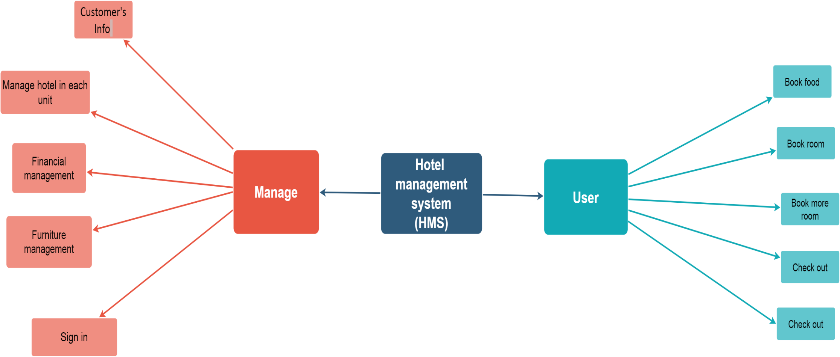

### **1.3 User Case Diagram**

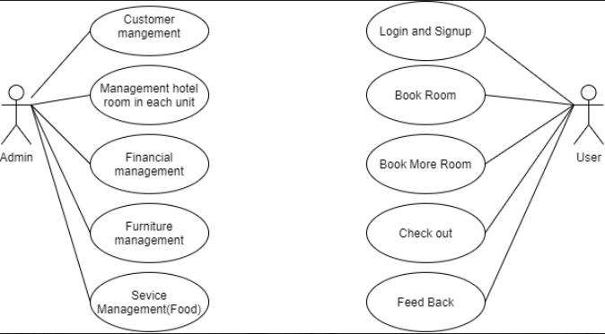

### **1.4 Use Cases List**

|  |  |  |  |
| --- | --- | --- | --- |
| **ID** | **Feature** | **Use Case** | **Description** |
| 01 | Customer's Info | Manager | Manage infomation of customer |
| 02 | Management hotel room in each unit | Manager | Manage all info about room |
| 03 | Financial management | Manager | Manage financial of hotel |
| 04 | Furniture management | Manager | Manage funiture of hotel |
| 05 | Sign in | User | User can log in |
| 06 | Book food | User | User can book food |
| 07 | Book Room | User | User can book room |
| 08 | More Book Rooms | User | User can More Book Rooms after book one room |
| 09 | Check out | User | Make payment, check out |
| 10 | Feedback | User | Give your own opinion |

### **1.5 Business Rules**

|  |  |  |  |  |
| --- | --- | --- | --- | --- |
| ***ID*** | ***Rule Definition*** | ***Type of Rule*** | ***Static or Dynamic*** | ***Source*** |
| BR-01 | A user who makes 10 unsuccessful purchases will block a 20-minute temporary purchase. | Action assertions | Dynamic |  |
| BR-02 | Do not register an account and declare fake information, name an account that is offensive or vulgar | Structural assertion | Dynamic |  |
| BR-03 | It is not allowed to post news related to matters that are not allowed by Vietnamese law. | Derivation | Static |  |
| BR-04 | The title and content of the post must be accented Vietnamese. It is forbidden to use vulgar words or culture. | Action assertions | Static |  |
| BR-5 | Must have account and can not booking a lot of motel | Action assertions | Dynamic |  |
| BR-12 | Do not create many accounts to post, if we find out it will delete and ban all nick. | Action assertions | Dynamic |  |
| BR-07 | Post must have imgage, address, contact of motel. | Action assertions | Dynamic |  |
| BR-06 | Users who enter incorrect information 5 times in a row  will be lockek out for 30 minutes. | Action assertions | Dynamic |  |

## 2. Hotel Management System Feature

### **2.1 Customer’s management**

|  |  |  |  |
| --- | --- | --- | --- |
| ID and Name: | UC - 1 Customer’s management | | |
| Created By: | Lê Trung Sang | Date Created: |  |
| Primary Actor: | Admin | Secondary Actors: | Web |
| Description: | Manage data of customer, example : id card, name, hotel's rental contract ,.....  Admin can delete,add cus, update the status of rent's room | | |
| Trigger: | Click button manage to enter manage page | | |
| Preconditions: | Admin account has been created.  Admin account has been authorized.  The admin's device was connected to the internet when logging in. | | |
| Postconditions: | The user has successfully logged in to the application.  The system records successful login activity. | | |
| Normal Flow: | 1. The admin accesses the website.  2. The admin chooses the method to log in with the account.  3. The admin enters the account and selects the login command.  4. The system verifies login information successfully and allows admin to access the website.  5. The system records successful login activity. | | |
| Alternative Flows: | If admin can not login to the system, report to the mod to be provide  another account. The system will return new account or fix account | | |
| Exceptions: | Wrong password, email not create or never exist but still use to create account | | |
| Priority: | Must have | | |
| Frequency of Use: | Account has been registered will be deploy database each time | | |
| Business Rules: |  | | |
| Other Information: | None | | |
| Assumptions: | None | | |

### **2.2 . Management hotel room in each unit**

|  |  |  |  |
| --- | --- | --- | --- |
| ID and Name: | UC – 2 Management hotel room in each unit | | |
| Created By: | Le Trung Sang | Date Created: |  |
| Primary Actor: | Admin | Secondary Actors: | Web |
| Description: | Provide some feature for manage hotel :   * Hotel's price * Info room * Service's price * ............. | | |
| Trigger: | Admin view all room , provide data for customer | | |
| Preconditions: | All of data in database, admin have account to access to view and edit or update it | | |
| Postconditions: | User is admin, user have been authorized by system(orginazation or company) | | |
| Normal Flow: | 1. Admin enter website and system will check account 2. Base on account , if system check oke, admin can view web and sort room | | |
| Alternative Flows: |  | | |
| Exceptions: | Admin can not access to the system | | |
| Priority: | High | | |
| Frequency of Use: | None | | |
| Business Rules: |  | | |
| Other Information: | None | | |
| Assumptions: | None | | |

### **2.3 . Financial management**

|  |  |  |  |
| --- | --- | --- | --- |
| ID and Name: | UC - 3 Financial management | | |
| Created By: | Trần Xuân Sơn | Date Created: |  |
| Primary Actor: | Admin | Secondary Actors: | Web |
| Description: | Manage the payment fee of motel | | |
| Trigger: | Admin checks the payment of rooms in the inn | | |
| Preconditions: | -Only administrators have this permission  -Must be connected to the internet | | |
| Postconditions: | View revenue and expenditure data of inn | | |
| Normal Flow: | 1. Admin access website.  2. Admin selects financial management item. | | |
| Alternative Flows: | None | | |
| Exceptions: | When user access use case stop | | |
| Priority: | Medium | | |
| Frequency of Use: | None | | |
| Business Rules: | None | | |
| Other Information: | None | | |
| Assumptions: | None | | |

### **2.4 . Furniture management**

|  |  |  |  |
| --- | --- | --- | --- |
| ID and Name: | UC - 4 Furniture management | | |
| Created By: | Trần Xuân Sơn | Date Created: |  |
| Primary Actor: | Admin | Secondary Actors: | Web |
| Description: | Manage furniture of motel | | |
| Trigger: | Admin checks furniture of rooms in the inn | | |
| Preconditions: | -Only administrators have this permission  -Must be connected to the internet | | |
| Postconditions: | View statistics of quantity, quality of furniture | | |
| Normal Flow: | 1. Admin access website.  2. Admin selects furniture management item. | | |
| Alternative Flows: | None | | |
| Exceptions: | When user access use case stop | | |
| Priority: | Medium | | |
| Frequency of Use: | None | | |
| Business Rules: | None | | |
| Other Information: | None | | |
| Assumptions: | None | | |

### **2.5. Book food**

|  |  |  |  |
| --- | --- | --- | --- |
| ID and Name: | UC - 5 Book food | | |
| Created By: | Bùi Đình Chung | Date Created: |  |
| Primary Actor: | User | Secondary Actors: | Web |
| Description: | Using the service of buying food from the website. | | |
| Trigger: | Users want to order food from the website. | | |
| Preconditions: | The user's device was connected to the internet when performing the service.  The user must be a guest of the hotel.  The amount in the account is greater than the amount to be paid. | | |
| Postconditions: | The user has successfully used the service.  The system records the successful service usage. | | |
| Normal Flow: | 1. The user visits the website.  2. The user chooses the method of ordering food and water.  3. The user confirms the purchase and clicks the purchase.  4. Successful purchase authentication system. | | |
| Alternative Flows: | None | | |
| Exceptions: | 1. Login failed or not connected to the internet.  2. The amount in the account is insufficient  3. Cancel purchase | | |
| Priority: | Must have | | |
| Frequency of Use: | None | | |
| Business Rules: | BR-01 | | |
| Other Information: | None | | |
| Assumptions: | None | | |

### **2.6 . Login and Signup**

|  |  |  |  |
| --- | --- | --- | --- |
| ID and Name: | UC – 6 Login and Signup | | |
| Created By: | Bùi Đình Chung | Date Created: |  |
| Primary Actor: | User | Secondary Actors: | Web |
| Description: | Log in to the app to use the service from the app. | | |
| Trigger: | User wants to log in to the site | | |
| Preconditions: | User account has been created.  User account has been authorized.  The user's device was connected to the internet when logging in. | | |
| Postconditions: | The user has successfully logged in to the application.  The system records successful login activity. | | |
| Normal Flow: | 1. The user accesses the website.  2. The user chooses the method to log in with the account.  3. The user enters the account and selects the login command.  4. The system verifies login information successfully and allows users to access the website.  5. The system records successful login activity. | | |
| Alternative Flows: | 1. The user chooses the method to log in with his gmail account.  2. The system switches to the gmail login screen.  3. The user enters the gmail account and selects the login command.  4. Gmail successfully validates the login information and allows the user to access the website. | | |
| Exceptions: | 1. The system has failed to validate the login information and displays a message.  2. The user chooses to cancel login.  3. The user chooses the command to retrieve the password. | | |
| Priority: | Must have | | |
| Frequency of Use: | None | | |
| Business Rules: | BR-06 | | |
| Other Information: | None | | |
| Assumptions: | None | | |

### **2.7. Book room**

|  |  |  |  |
| --- | --- | --- | --- |
| ID and Name: | UC - 7 Book room | | |
| Created By: | Bùi Duy Khải | Date Created: |  |
| Primary Actor: | User | Secondary Actors: | Web |
| Description: | Describe the process used to add a new booking | | |
| Trigger: | Users want to booking room from the website. | | |
| Preconditions: | 1. Room is exist  2. User login account | | |
| Postconditions: | Room have address, price, status | | |
| Normal Flow: | 1. The user visits the website.  2. The user chooses the room want to booking  3. Website show image room, room status, price...  4. If user chooses this room, change room status | | |
| Alternative Flows: | None | | |
| Exceptions: | 1. Login failed or not connected to the internet.  2. 2 users booking at the same time | | |
| Priority: | Must have | | |
| Frequency of Use: | None | | |
| Business Rules: | None | | |
| Other Information: | None | | |
| Assumptions: | None | | |

### **2.8. More rooms book**

|  |  |  |  |
| --- | --- | --- | --- |
| ID and Name: | UC - 7 More rooms book | | |
| Created By: | Bùi Duy Khải | Date Created: |  |
| Primary Actor: | User | Secondary Actors: | Web |
| Description: | Describe the process used to add one more new booking | | |
| Trigger: | Users want to booking room from the website. | | |
| Preconditions: | 1. Room is exist  2. User login account | | |
| Postconditions: | Room have address, price, status | | |
| Normal Flow: | 1. Check user have been booked room yet  2. The user chooses the room want to booking  3. Website show image room, room status, price...  4. If user chooses this room, change room status | | |
| Alternative Flows: | None | | |
| Exceptions: | 1. Login failed or not connected to the internet.  2. 2 users booking at the same time | | |
| Priority: | Must have | | |
| Frequency of Use: | None | | |
| Business Rules: | None | | |
| Other Information: | None | | |
| Assumptions: | None | | |

**2.9. Check out**

|  |  |  |  |
| --- | --- | --- | --- |
| ID and Name: | UC - 9 Check out | | |
| Created By: | Ngô Anh Tu | Date Created: |  |
| Primary Actor: | User | Secondary Actors: | Web |
| Description: | Make payment, check out | | |
| Trigger: | When the user does not want to rent a room | | |
| Preconditions: | Users are in the status of renting a room or making a reservation | | |
| Postconditions: |  | | |
| Normal Flow: | View information, rental times as well as total prices  Make a payment  Feedback if have | | |
| Alternative Flows: | None | | |
| Exceptions: | Customers do not have enough money  There was an error in the payment system | | |
| Priority: | Must have | | |
| Frequency of Use: | None | | |
| Business Rules: |  | | |
| Other Information: | None | | |
| Assumptions: | None | | |

**2.10. Feedback**

|  |  |  |  |
| --- | --- | --- | --- |
| ID and Name: | UC - 10 Feedback | | |
| Created By: | Ngô Anh Tu | Date Created: |  |
| Primary Actor: | User | Secondary Actors: | Web |
| Description: | Collect user comments | | |
| Trigger: | When a user has some reviews like or dislike something | | |
| Preconditions: | Users are in the status of renting a room or making a reservation | | |
| Postconditions: | Internet is required | | |
| Normal Flow: | Give your own opinion  Feedback about the system | | |
| Alternative Flows: | None | | |
| Exceptions: | Server error | | |
| Priority: | Must have | | |
| Frequency of Use: | None | | |
| Business Rules: |  | | |
| Other Information: | None | | |
| Assumptions: | None | | |